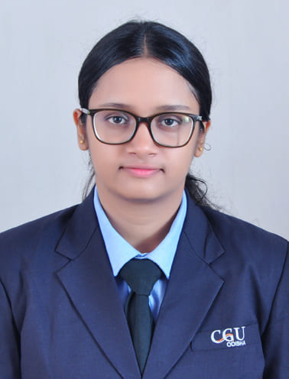JAYASHREE BEHERA

91+ 9337850065 | [jayashree251204@gmail.com](mailto:jayashree251204@gmail.com) | Bhubaneswar, Odisha

LinkedIn: <https://www.linkedin.com/in/jayashree-behera-895394289>

GitHub: <https://github.com/Jayashree-04>

**Profile Summary**

As a passionate and enthusiastic B Tech student in Computer Science, I have a good foundation in data structure and embedded language. And also having a keen interest in Machine Learning.

**Education**

**Saint Arnold’s School** 2020

10th Percentage: 85.6

**St Xavier High School** 2022

12th Percentage: 74.8

**C. V. Raman Global University** 2022-2026

B. Tech in Computer Science and Engineering CGPA: 8.22

**Training and Internship**

**Embedded C [July 2023]**

* Study on STM Microcontroller
* Introduction to STM Cube IDE, writing header files, Nucleo64 Board schematics, using register-level programming and monitoring variables in STMcube IDE

**Projects**

* Personalized E-Learning Platform

**Courses and Certification**

* Acquired Udemy HTML & CSS course, helped in enhancing my skills towards web development
* Earned a Google UX Design Professional Certificate
* 2024 Aspire Leaders Program [August 2024]: This program has a good outcome with increased self-confidence, sharpened critical thinking skills, refined communication skills, and a desire to create a social impact among a global community.
* Acquired Introduction to Cybersecurity Certificate from CISCO

**Skills**

C, Java, Python, SQL, HTML, CSS

**Extracurricular**

* Participated in Odisha Skills 2023
* Participated in Smart India Hackathon 2022 and our team was among Top 40 in college
* Won Robo Sumo competition once